**Section 1: Birth of the Buddha Gotama**

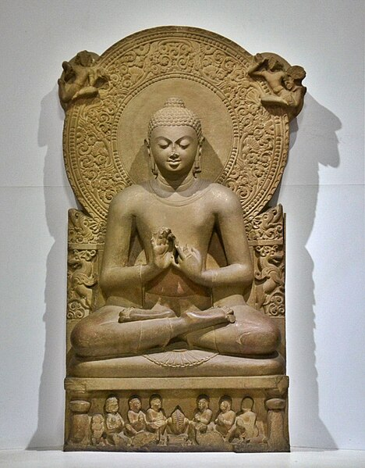In this section we will focus on the significance of the birth of Buddha as a bodhisatta and important incidents connected to his appearance in this world. Although the Tipitaka does not mention the details of the time of the Buddha's birth, according to South East Asian tradition it is accepted that the Buddha Gotama was born in 623 B.C. on the full moon day of the month of May (Vesākha -Vesak) [1]. Most of his life he lived in the northern part of India, then known as ‘Middle Country” (*majjhimadesa)*.[2]

**Buddha in Sarnath Museum (Dhammajak Mutra):** Source: Tevaprapas Makklay : Picture Courtesy:

<https://commons.wikimedia.org/wiki/File>:

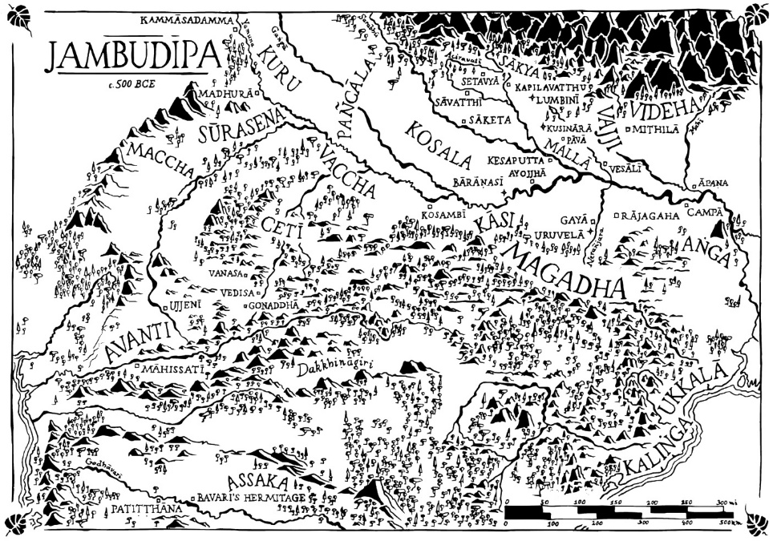

**Map showing the Jambudȋpa during the time of Gotama Buddha**

source: Suttacentral : <https://suttacentral.net/>

**▲Why the Birth of the Buddha is Significant?**

The Buddha and his Dhamma—teachings are a vital source of wisdom and guidance for spiritual development. The significance of a Buddha in a human realm is that an enlightened being, a teacher who can guide people through suffering and discontent to the ultimate goal of Nibbāna [3] , becomes available to humankind. The following extract from the scriptures focus on the significance of the birth of the Buddha:

*“… there is one person who arises in the world for the welfare of many people, for the happiness of many people, out of compassion for the world, for the good, welfare, and happiness of devas and human beings … Who is that one person? The Tathāgata, the Arahant, the Perfectly Enlightened One…” [4]*

**\* Below is an extract from Light of Asia on the Buddha descending to this world**

“…and on Lord Buddha, waiting in that sky,

Came for our sakes the five sure signs of birth

So that the Devas knew the signs, and said

”Buddha will go again to help the World.”

”Yea!” spoke He, “now I go to help the World

This last of many times; for birth and death

End hence for me and those who learn my Law.

I will go down among the Sākyas,

Under the southward snows of Himalay,

Where pious people live and a just King.” [5]

**▲The Bodhisatta descends from the** **Tuṣita Deva Realm**

According to Buddhist scriptures, the Buddha was born in a human realm as a Bodhisatta [6], having spent a period of time in the “deva” realm of Tuṣita’ [7].

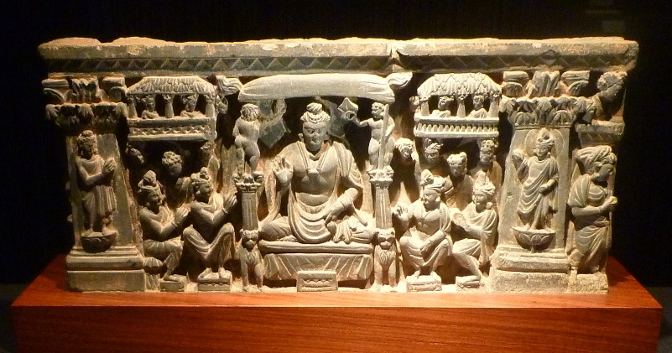

**Righ: Bodhisatta in Tuṣita Heaven** -Stone carving during the [Kushan Dynasty](https://en.wikipedia.org/wiki/Kushan_Dynasty). Picture courtesy: Wikipedia

Venerable Ānanda [8] is quoted in the suttas, describing the birth of the Buddha:

*“…I heard and learned this, Venerable Sir, from the Blessed One’s own lips: ‘Mindful and fully aware…the Bodhisatta appeared in the Tusita heaven …the Bodhisatta remained in the Tusita heaven …the Bodhisatta passed away from the Tusita heaven” and descended into his mother’s womb”* [9] .

**▲ The Bodhisatta was Born to a Royal Family**

The Bodhisatta’s parents were King Suddhodana and Queen Mahamaya from the royal capital Kapilavattu in the Sakyan province [10]. Traditional Buddhist stories says that when the bodhisatta descended into the womb of Queen Mahamaya, she had a dream that a pure white elephant came near her bed [11].

**Queen Maya’s Dream**

“One full moon night, sleeping in the palace, the queen had a vivid dream. She felt herself being carried away by four devas to Lake Anotatta in the Himalayas. After bathing her in the lake, the devas clothed her in heavenly cloths, anointed her with perfumes, and bedecked her with divine flowers. Soon after a white elephant, holding a white lotus flower in its trunk, appeared and went round her three times, entering her womb through her right side”.

**Quote from**: <https://www.buddhanet.net>

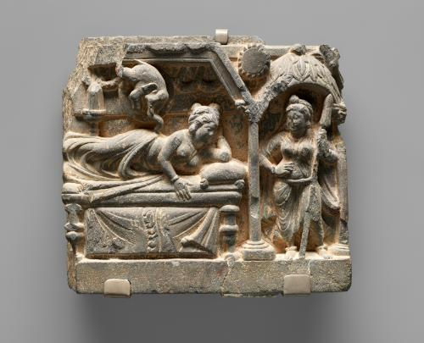

**Queen Maya’s dream**- 2nd century Gandharan Sculpture. Picture Courtesy: Wikipedia- https://en.wikipedia.org/wik

**▲ The Birth of the Bodhisatta at Lumbini Park**

According to legend, King Suddhodana’s wife, Queen Maya left the city of Kapilavattu for her parents’ home in Devadaha to give birth to her child, the future Buddha. On the way, the Queen saw a beautiful park (Lumbini) with fragrant Sal flowers in bloom. She entered the park with her entourage, bathed in a pond and walked towards a Sal tree and touched a branch full of flowers, at that moment the Bodhisatta was born [12]

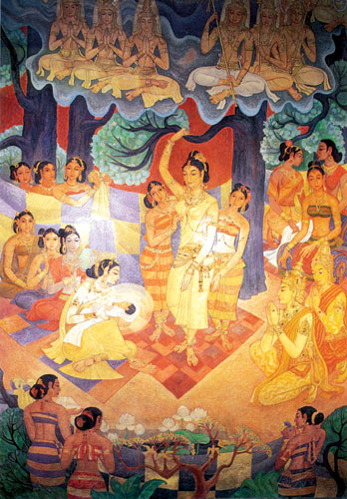

**Queen Maya Devi giving birth to the baby prince at Lumbini Grove:** Picture courtesy: Daham Sabawa

https://dahamsabava.wordpress.com/

(do need permission?)

▲ **Significant Events Occurred at the Birth**

According to the scriptures, the birth of a Bodhisatta was distinctive, as is evident from the following statement by Venerable Ãnanda:

*♦* **Great Power**

“ **I heard and learned this from the Blessed One’s own lips:**

*… ‘other women give birth seated or lying down, but not so the Bodhisatta’s mother. The Bodhisatta’s mother gave birth to him standing up…when the Bodhisatta came forth from*

*his mother’s womb, he did not touch the earth. The four young gods received him and set him before his mother saying: ‘****Rejoice, O queen, a son of great power has been born to you****…’ then a great immeasurable light surpassing the splendour of the gods appeared in the world’*”[13]

♦ **Utterance at the Birth**

Scriptures say that as soon as the Bodhisatta was born, he stood firmly with his feet, and walked seven steps facing north; a whit a white parasol held over him, he surveyed each quarter and uttered:

*“I am the highest in the world; I am the best in the world;*

*I am the foremost in the world. This is my last birth;*

*now there is no renewal of being for me.”* [14]

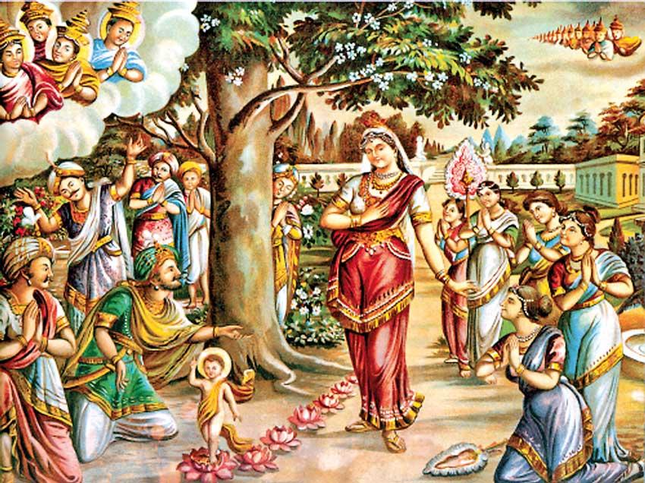

**The Bodhisatta taking seven steps** by Sri Lankan artist M. Sarlis (temple wall painting) [15]

**Note:** Information of theSeven Steps are given here [16].

* **The Birth of Bodhisatta is glorified in the following poem of Aśvaghoṣa**

In that glorious grove, perceiving that it was time for the birth,

The queen took to a bed covered over with an awning,

being joyfully received into the bosom of thousands of fellow women.

Then, as a propitious moon passed into the asterism of Puṣya,

to that queen sanctified by the manner of her action –

Through her, for the welfare of the world –

a son was born, painlessly and healthily.

With brightness he shone, and with constancy,

like a newly-risen sun inundating the earth;

Thus, he blazed too brightly to be gazed upon,

and at the same time, he stole the eyes,

in the manner of the hare-marked moon.

For with the blazing light of his body,

he blotted out the light of lamps as does the sun;

And with his beautiful lustre of precious gold,

he enlightened all directions.

With even footsteps, his feet rising up like water-born lotuses,

and coming down in long stamping strides:

Seven such firm steps he took, looking like the Seven Seer cluster of stars **[17]**.

**▲ Devas Rejoice in the Birth of Bodhisatta**

Corresponding to scriptures, Sakka, the King of the Devas [18] and his retinue celebrated the

birth of the Buddha. The Seer Asita [19], witnessing the celebration of Devas, asked the reason for the celebration. Then Devas replied thus:

“*The being intent on awakening, a peerless gem, has been born in the human realm for the sake of their welfare and happiness, in Lumbinī, a village in the Sakyan land. That’s why we’re so happy and in such excellent spirits. He is supreme among all beings, the best of people, chief of men, supreme among all creatures. He will roll forth the wheel in the grove of the seers, roaring like a mighty lion, lord of beasts*.” [20]

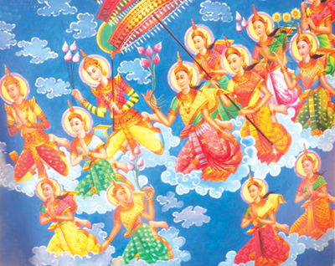

**Sakka the king of devas and his retinue rejoicing the birth of the Bodhisatta**, Picture Courtesy: <https://budusarana.lk/>

(need permission?)

**▲ Lumbini Park is the Place of Birth of the Gotama Buddha**

In the Nepalese language ‘Lumbini’ means lovely. Tradition as well as also scriptures say that Lumbini, the Buddha’s birth place was located in the Sakyan Kingdom of North India (called Middle Country). Above we saw a verse sung by the devas rejoicing of the birth of the Buddha thus:

*“The being intent on awakening, a peerless gem, has been born in the human realm for the sake of welfare and happiness, in Lumbinī, a village in the Sakyan land”* [21]

♦ In the Pabbaja sutta of Suttanipata, replying to an inquiry by King Bimbisara of Magadha about his birth, the ascetic Siddhartha said this:

*‘Up north, O King, on the slopes of the Himalayas,*

*full of wealth and strength, lies the land*

*of one whose abode is among the Kosalans.*

*Their clan is named for the Sun,*

*they are Sakyans by birth.*

*I have gone forth from that family—”* [22].

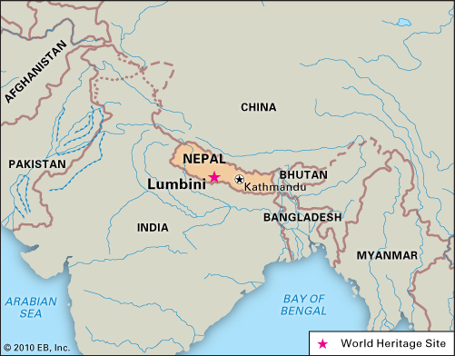

**♦ The modern map of India** (above) indicates that Lumbini is located in Nepal, near the border of India. During the Buddha’s life, the Indian subcontinent, including now Nepal, was known as Jambudȋpa. According to Buddhist scriptures, the Blessed One’s native place was called, Kapilavattu, the royal capital of the Sakyans, hence Lumbini is believed to have been located near the royal capital of Kapilavattu. Previously we saw the statement of Ascetic Siddhartha to King Bimbisara that he was from the Sakyan country, situated on the slopes of the Himalaya Mountain range [23]. In the map below we can see that Kapilavattu is located below the Himalaya range.

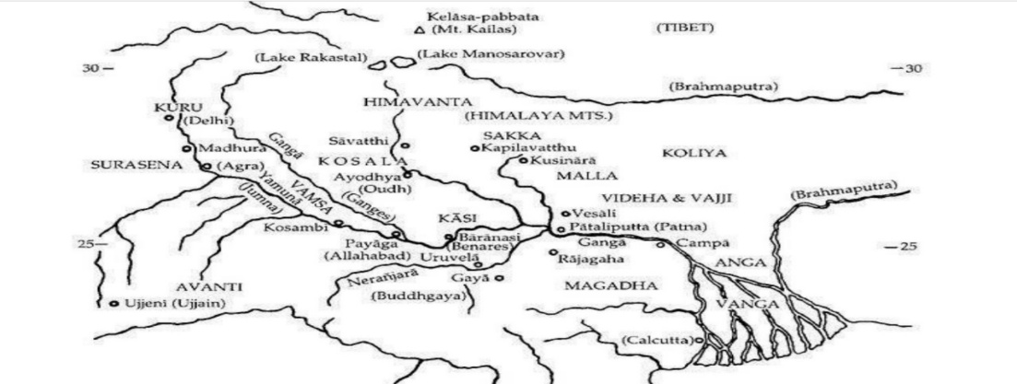 **Map showing the main provinces of North India during the time of the Buddha**

**Source:** Buddhist India byT. W. Rhys Davids.

**▲Evidence from Historical Sources of Lumbini as the Birth Place of the Buddha**

**♦Asoka Pillar**

According to history and archaeology, the first evidence from non-scriptural sources came through the discovery of an ancient pillar called the ‘**Asoka Pillar at Lumbini**’ built by the emperor Asoka. It seems that the King Asoka who became a follower of the Buddha, went on a pilgrimage to discover Buddhist sites around 248 B.C. (3rd century). When he visited Lumbini park, he built the monument as a mark of respect to the Buddha. [24]

The discovery of the Asoka Pillar in Lumbini [25] in 1896 was an important finding. In the Mahā Parinibbāna Sutta (DN:16), the place where the Buddha was born is mentioned as one of the four places suitable for devoted Buddhist to visit and remember the greatest qualities of the Blessed One. [26]

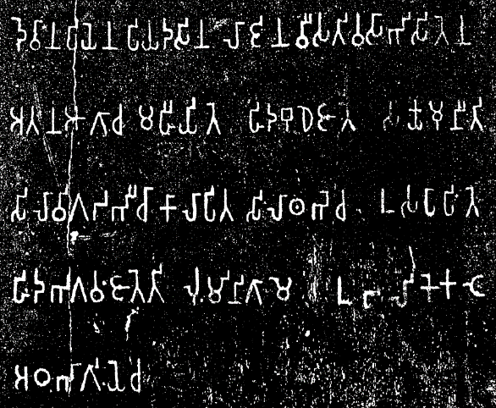

**Inscriptions on the Asoka Piller**

*Devānaṃpiyena Piyadasina lājina vīsati-vasābhisitena- atana āgāca mahīyite hida Budhe jāte Sakyamuni ti- silā vigaḍabhī cā kālāpita silā-thabhe ca usapāpite-* ***hida Bhagavaṃ jāte ti Luṃmini-gāme*** *ubalike kaṭe aṭha-bhāgiye ca.*

**Source:** wikipedia.org/

**The translation:**

“When King Devanampriya Priyadarsin had been anointed twenty years, he came himself and worshipped (this spot) because the [Buddha Shakyamuni](https://en.wikipedia.org/wiki/Buddha_Shakyamuni) was born here. (He) both caused to be made a stone bearing a horse and caused a stone pillar to be set up, (in order to show) that the Blessed One was born here. (He) made the village of [Lummini](https://en.wikipedia.org/wiki/Lumbini" \o "Lumbini) free of taxes, and paying (only) an eighth share (of the produce)” Source: Wikipedia.

**Below** Left**:** Excavation of Asoka’s Piller in Lumbini. **Right:** Modern day Lumbini Piller: picture courtesy: Wikipedia.

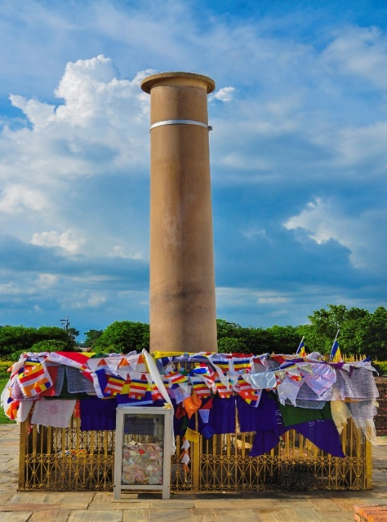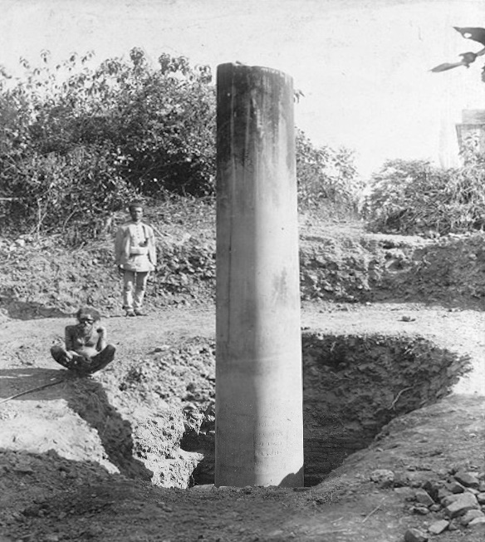

**♦ Travelling Monks from China visiting India**

The other significant events documenting Lumbini as the birthplace of the Buddha came from the two Chinese monks, **Faxian**, in the 5th century and **Xuanzang** in the 7th century. They were on a pilgrimage from China to India visiting ancient Buddhist sites. These two famous travellers from the Far East who visited Lumbini and many other important Buddhist palaces, recorded their travel encounters which later supported the archaeologists andother interested parties in locating the birth place of the Buddha and other similar sites. [27]

**Below: Ancient site of Lumbini**, before the new constructions: Picture courtesy: UNESCO World Heritage Convention

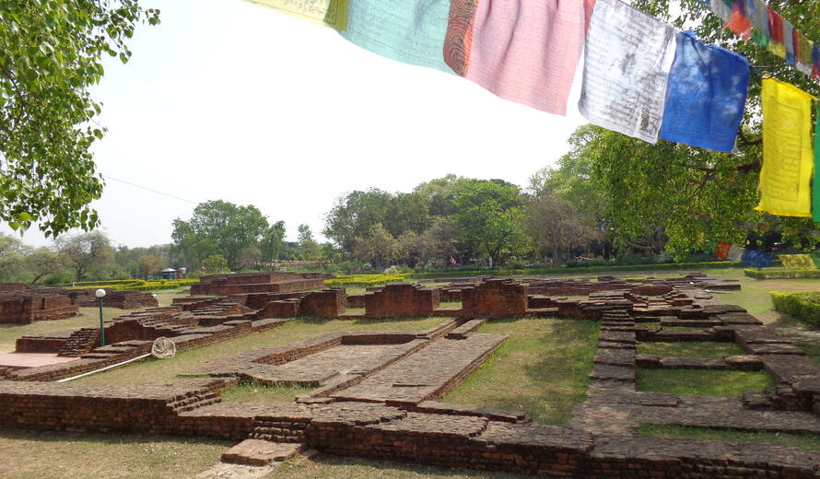

**Below: Modern day Lumbini Park**: picture courtesy: 1. World History Encyclopedia

2 Dreamstime.com.

**▲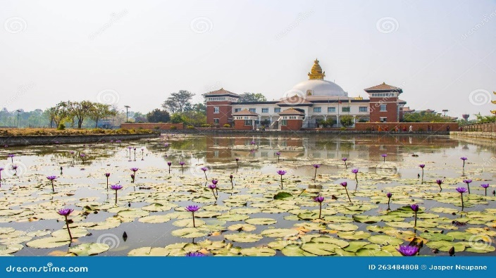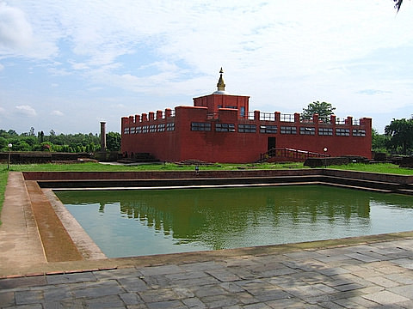The Buddha was from Sakyan Clan**

Numerous places in the scriptures point out that the Buddha belonged to the Sakyan clan, hence he was called ‘Sakya Muni’ (sage of Sakyan) and his disciples were called ‘Sakya Putta’ (son of Sakyans). The Sakyan’s Republic was on the edge of the Himalayas and Kapilavattu was their royal capital. The Sakyan Republic was subject to the King of Kosala. Tradition as well as scriptures say that King Okkaka was the forefather of the Sakyan clan. In Ambaṭṭha Sutta (DN:3), we can see a passage related to this:

♦ The Buddha said thus:

*“…for the Sakyans regard King Okkāka as their ancestor. At one time King Okkāka, to whom his queen was dear and beloved, wishing to transfer the kingdom to her son, banished his elder brothers from the kingdom — made their home on the flank of the Himālayas beside a lotus-pond where there was a big grove of teak-trees…Then King Okkāka asked his ministers and counsellors: ‘Where are the princes living now?’ and they told him. At this King Okkāha exclaimed: “They are strong as teak (sāka), these princes, they are real Sakyans!” …and that is how the Sakyans got their well-known name. And the King was the ancestor of the Sakyans…*’[28]

♦ Sakyan (called *khattiya*) were rulers and considered to be proud people. During the Buddha’s time there were four classes: Brahmins who served as priests and scholars, Kshatriyas were warriors who were kings and rulers; Vaishyas were merchants and traders and; Shudras were labourers’ and servants. Some of the attributes given to Sakyan are given below:

* “*The khattiya is the best among people for those whose standard is the clan…”* [29]

* *“…aim of khattiyas; their quest is for wisdom; their support is power; they are intent on territory; and their final goal is sovereignty*.” [30]

♦ Tradition says that Kapilavattu had been named in honour of the sage Kapila. When the banished princes of King Okkāka, went to the Himalayan range searching for a place to live, they saw the hermitage of sage Kapila, who welcomed them and helped them to settle down near his hermitage. Later when they resorted to their own royal status, they built a city and named it Kapilavattu to show their gratitude to sage Kapila [31]

♦ In Mahâpadāna Sutta (DN:14) there is a passage where the devas’ mention that the city of Kapilavatthu is the native place of the Buddha:

*“…in this fortunate aeon now, the Lord Buddha has arisen in the world… his father is King Suddhodana, his mother was Queen Maya, and his royal capital is Kapilavattu…”.*

♦ According to Mahāparinibbāna sutta (DN:16): When the Buddha passed away, the Sakyans from Kapilavatthu demanded relics of the Buddha thus:

*“…the Sakyas of Kapilavattu heard (Parinibbana of the Buddha), and they sent a message: ‘The Lord was the chief of our clan. We are worthy to receive a share of the Lord’s remains, and we will make a great stupa for them… the Sakyans of Kapilavattu built one (stupa) at Kapilavattu”.*

**▲ Location of Kapilavattu**

The map below shows the modern locations of Kapilavattu 1) site is in present day Nepal and the 2) site in Piprahawa of India.

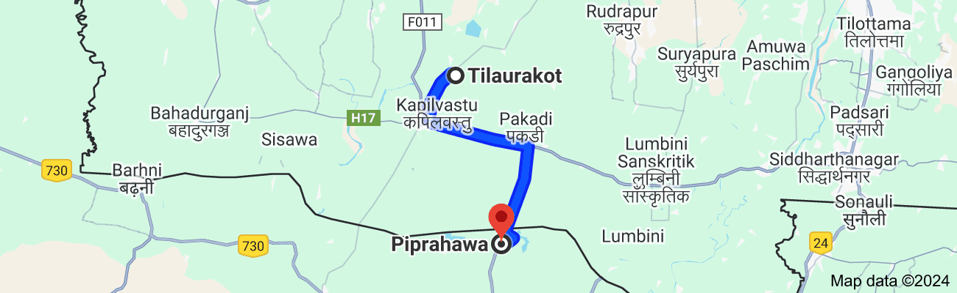

♦ During the life of the Buddha, Kapilavattu was a well-known city in the northern part of Jambudvipa- now called the Indian sub-continent. The Sakyan Mahānāma a prominent member of Sakya clan, said this:

*“… this Kapilavatthu is rich and prosperous, populous, crowded, with congested thoroughfares. In the evening, when I am entering Kapilavatthu after visiting the Blessed One or the bhikkhus worthy of esteem, I come across a stray elephant, a stray horse, a stray chariot, a stray cart, a stray man (roaming excitedly) …”* [32]

♦ According to tradition as well as scriptures it is said that Kapilavattu was destroyed by King Vidudabha, son of late king Pasenadi Kosala [33] .

* **Ruins of that city,** the native place of the Buddha were discovered not long ago during the time of British India (1858-1947); archeologists found two possible sites, near the Nepal-Indian border, one in Nepal and the other in India. The site in Nepal is called Tilaurakot located in present day Kapilavattu District, and the other site is Piprahwa, a village near Siddharthnagar, in state of Uttar Pradesh, India [34].

The controversy over the exact location of Kapilavattu is still unresolved. The map (above) shows that the two sites are not very far from each other (about 27 km apart) and are both close to, Lumbini, where prince Siddhartha was born. Below are the pictures of the two sites:

Below: **Stupa at Piprahwa village in Uttar Pradesh, India**: picture courtesy: Wikipedia

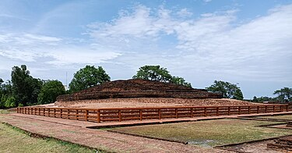

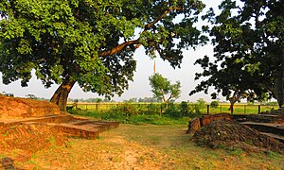

T**he east gate at the Tilaurakot archaeological site in Nepal:** picture courtesy: Wikipedia

**◙ Summery**

In this section we have briefly described the birth of Gotama Buddha and significant events occurred during that time.

* Buddha Gotama was born in 623 B.C. as a sakyan prince @ Lumbini Park of Sakyan province. Parents were King Suddhodana and Queen Mahamaya from the royal capital Kapilavattu

* Why Appearance of the Buddha in the world is a unique event? Because he found the lost path to the liberation and shared his knowledge and experience with other beings who were benefited from his teachings.

* According to scriptures Lumbini is one of the four holy place for Buddhist pilgrims (recommended by the Blessed One in DN:16 (Mahaprainibbana sutta). Seen the birth place of the Buddha would helps devotees to strengthen their faith, to inspire the urgency of releasing from samsara suffering. They would remember how the Blessed One urged his followers to be diligent and make haste to achieve liberation.

*There are archeological and historical evidence to prove the birth of our Buddha Gotama was occurred at Lumbini.

* Due to archeological evidence, there are 2 sites found as the Royal capital of Kapilavattu. This matter is not yet solved but most of the modern-day pilgrims visit both sites.

**End Notes: Section 1**

1. “**Siddhartha Gotama** who became the Buddha, the Enlightened One, may have lived from about 563-483 B.C., though many modern scholars suggest a later dating. Oriental traditions offer a number of alternative dating’s; that favoured in Sri Lanka and South-East Asia being 623-543…” **Source:** DN: Introduction: Life of the Buddha, by Maurice Walshe). *He was born on the full moon of Vesākha (May) in year 68 Mahā Era. **Source:** The Great Chronicles of Buddhas by Venerable Mingun Sayadaw (<https://www.bps.lk/olib/mi/mi014.pdf>)
2. Unlike the Christian Era, the Buddha Era is reckoned from the death of the Buddha, which occurred in 543 BCE (in his 80th year), and not from his birth. * See: Buddha and his teachings by Venerable Narada Mahathera, p. 3. * For details regarding **‘Middle country’** see: section 14.
3. * **Nibbāna** (Pali)/ Nirvana (Sanskrit): the state that when ignorance and craving have been uprooted is called Nibbāna; the extinguishing of all worldly desires—iberation from all sufferings. * For more information: SN: 43:1 & 2, DN: Kevaddha sutta, Iti:43 * **Nibbana:** **Introduction to Majjima Nikaya** by Bhikkhu Bodhi.
4. Source:AN1:170.* **Tathāgata:** refers to one who has attained Supreme Enlightenment:; it is one of the titles given to the Buddha; whatever the Tathāgata speaks, utters, or expounds in the interval between the night when he awakens to the unsurpassed perfect enlightenment and the night when he attains final nibbana- all that is just so and not otherwise; therefore he is called the Tathāgata: **see:** AN:4:23, SN:45:139.
5. Quote from **The Light of Asia by Edwin Arnold**, PBS: Wheel no29, 1980.
6. “A being intended to become a future Buddha- is called Bodhisattva. During the time of the Buddha Dipankara, an asetic named Sumedha (Gotama Buddha) performing duties at the feet of the Buddha, aspired to obtain Buddha-hood, spent many aeons in the world system. After fullfilling all bodisattva duties, he paased away from the human world and appeared in the Tuṣita heaven as the future Buddha to be:**see**: KN: Buddhvamsa-Chariyapitaka: Sumedha Katha. **Note**: The Bodhsatta in Tusita was called Deva Setaketu,  **source**: The story of Sataketu Deva, The Great Chronicles of Buddhas by Venerable Mingun Sayadaw.
7. Tuṣita is one of the 6 deva realms above the human realm; A single night and day is equivalent to four hundred human years; the life span of those devas is four thousand such celestial years. In this realm all Bodhisattas, the Buddha to be reside, until the time came to be born in thre human world and become a fully enlightened Buddha. **See:** AN:8: 41.
8. Ānanda Thera was a cousin of the Buddha, he was called the Treasurer of the Dhamma. He was the Buddha’s chief attendant during the last 25 years of the Blessed One’s life. For more information **see**: ‘Great Disciples of the Buddha by Bhikkhu [Nyanaponika](https://www.amazon.com.au/Nyanaponika/e/B001HPZUT8/ref=dp_byline_cont_ebooks_1)  & [Hellmuth Hecker](https://www.amazon.com.au/s/ref=dp_byline_sr_ebooks_2?ie=UTF8&field-author=Hellmuth+Hecker&text=Hellmuth+Hecker&sort=relevancerank&search-alias=digital-text), Wisdom publication & <https://dahampada.github.io/>.
9. See: MN:123 * A similar description is given in AN4: 127 : ‘when the Bodhisatta enters his mother’s womb … a measureless glorious radiance becomes manifest, surpassing the divine majesty of the devas’.  **\*** Per Bhikkhu Bodhi: This refers to the Bodhisatta’s rebirth in the Tusita heaven, which followed his preceding human existence as Vessantara and preceded his birth in the human world as Siddhattha Gotama, **see**: AN: Notes: 1161, p.1169 **\*** “The last life of the Bodhisatta, before appearing in Tusita Heaven is described in Vessantara jātaka: see: Jataka Tales.
10. DN:14 : describe that the parents of the Buddha were: King Suddhodana and Queen Maya of the Royal Capita, Kapilavatthu.
11. It is stated that the Bodhisattva was conceived in the mother’s womb on the full moon of Asalha (Esla) ; for details of this event see: Mahamaya; Dream: The Great Chronicles of Buddhas by Venerable Mingun Sayadaw.
12. For details see: Mahamaya’s journey to Devadaha city: The Great Chronicles of Buddhas by Venerable Mingun Sayadaw.
13. **See**: MN:123.
14. **See**: Ibid.
15. M. Sarlis was the pioneer Buddhist revivalist painter of Sri Lanka in the early 20th century. His unique style is admired by generations. He was brilliant sculptor, and as a muralist: for more information see: https://archives.sundayobserver.lk/2010/10/10/mon17.asp
16. The special events that occurred at the birth of Bodhisatta explains each as a foretoken of the Buddha’s later attainments. Thus, his standing with his feet (pāda) firmly on the ground was a foretoken of his attaining the four bases for spiritual power (iddhipāda); his facing the north, of his going above and beyond the multitude; his seven steps, of his acquiring the seven enlightenment factors; the white parasol, of his acquiring the parasol of deliverance; his surveying the quarters, of his acquiring the unobstructed knowledge of omniscience; his uttering the words of the Leader of the Herd, of his setting in motion the irreversible Wheel of the Dhamma; his statement “This is my last birth,” of his passing away into the Nibbāna element with no residue remaining” **see**: MN: Notes: 1165, p.1169 * For more details of the story, see: The Bodhisatta’s Extraordinary Acts: The Great Chronicles of Buddhas by Venerable Mingun Sayadaw
17. Aśvaghoṣa's Buddhacarita is a Sanskrit poem written in India on the legendary history of Buddha; he was the spiritual advisor to the Indian King, Kanishka, during 1st century: see: Translations of Aśvaghoṣa's Buddhacarita by Mike Cross.
18. Sakka, the ruler of the Tavatimsa Deva Realm, is a follower of the Buddha and becomes a stream-winner; for more information **see:** SN:11.
19. Asita or Kaladevala or Kanhasiri was a great [ascetic](https://en.wikipedia.org/wiki/Asceticism) who lived during the time of the birth of prince Siddhartha. For details see:Snp:3.11.
20. **See**: Snp:3.11: (Nālaka sutta translated from Pali by Bhikkhu Sujato, www.suttacentral.com)
21. Ibid.
22. **See**: Snp:3.1 (Pabbaja sutta translated by Bhikkhu Sujato, www.suttacentral.com)

    * The encounter of Ascetic Siddhartha with King Bimbisara happened after the prince renounced his lay life, which will come later in this work.
23. **See**: Sn:3.1 Pabbaja sutta translated by Bhikkhu Sujato, www.suttacentral.com
24. King Aśoka, the third monarch of the Mauryan dynasty in the third century B.C., was the first ruler of a unified India and one of the greatest political figures of all time **see**: King Asoka and Buddhism: edited by Anuradha Seneviratna: PBS:1994
25. The **Lumbini pillar inscription**, also called the **Paderia inscription**, is an inscription in the ancient [Brahmi script](https://en.wikipedia.org/wiki/Brahmi_script), discovered in December 1896 on a [pillar of Ashoka](https://en.wikipedia.org/wiki/Pillars_of_Ashoka) in [Lumbini](https://en.wikipedia.org/wiki/Lumbini), [Nepal](https://en.wikipedia.org/wiki/Nepal) by former [Chief of the Nepalese Army](https://en.wikipedia.org/wiki/Chief_of_the_Nepalese_Army) General [Khadga Shamsher Jang Bahadur Rana](https://en.wikipedia.org/wiki/Khadga_Shamsher_Jang_Bahadur_Rana) under the authority of Nepalese government and assisted by [Alois Anton Führer](https://en.wikipedia.org/wiki/Alois_Anton_F%C3%BChrer)… Initially, only the top of the pillar was visible, with a Medieval inscription on it. The Nepalese authorities dug around the pillar, to find the ancient [Brahmi](https://en.wikipedia.org/wiki/Brahmi) inscription, which therefore had

    remained underground, hidden from view. The Brahmi inscription on the pillar gives evidence that [Ashoka](https://en.wikipedia.org/wiki/Ashoka), emperor of the [Maurya Empire](https://en.wikipedia.org/wiki/Maurya_Empire), visited the place in 3rd-century BCE and identified it as the birth-place of the Buddha :**See:** Wikepedia. * The architectural remains at the Maya Devi Temple include a pillar constructed by Emperor Ashoka in 249 BC, which contains inscriptions testifying to its location as the birthplace of the Buddha. Additional excavated remains of Buddhist monasteries and stupas dated between the 3rd century BC and the 15th century AD provide evidence around how Lumbini has been an important Buddhist pilgrimage site for centuries. The [**UNESCO website**](https://whc.unesco.org/en/list/666) calls Lumbini “one of the most holy and significant places for one of the world’s great religions” and visitors liken it to a “Mecca for Buddhists.” **see**: WHS:https://worldheritagesites.net/lumbini-birthplace-of-buddha/
26. “There are, O monks, four places on earth which a believing householder's son or a believing householder's daughter should commemorate as long as they live. Which are those four? –here the Blessed One has been born –here the Blessed One has attained the Sambodhi-enlightenment –here the Blessed One has turned the Wheel of the Dhamma”–here the Blessed One has attained the ‘Mahaparinibbāna’**…: see:** DN:16.
27. **Faxian,** was one of the first and perhaps the oldest Chinese monk to travel to India. … Faxian’s

    ‘**A Record of the Buddhist Kingdoms’**(translated by James Legge); he describes the conception of the Buddha at Kapilavatthu, his birth in a garden in Lumbini, and the attainment of nibbāna at Kuśinagara. * One of **Xuanzang’**s main reasons to undertake the arduous journey to India was to visit its sacred Buddhist sites… Thus, ‘**The Records of the Western Regions’** is a rich resource for historians, archaeologists, Buddhologists, and those interested in studying cross- cultural interactions in the premodern world: **see:** Association for Asian studies <https://www.asianstudies.org/publications/>
28. **See:** DN: 3 .
29. **See:** SN: 21:112 ( Mahakappina sutta).
30. **See:**AN6:52 (Khattiya sutta)
31. **Source:** https://www.wisdomlib.org/definition/okkaka
32. **See:** SN:55:21 ( Mahānāma sutta)
33. Prince Viḍūḍabha, the heir to the throne, was begotten from another wife of Pasenadi, Vāsabhā-khattiyā, a Sakyan lady of mixed descent who was passed off to Pasenadi as a pure-bred Sakyan princess. Viḍūḍabha later usurped the throne and left his father to die in exile. When he learned that the Sakyans had deceived his father he massacred them and almost decimated the entire Saykan clan, see: SN: Notes: 238, p.535.
34. **Notes:** British landowner named William Claxton Peppe was clearing land at his estate in India near the **village Piprahwa** and excavated a large mound of earth from which emerged a brick stupa. At a depth of 18 feet, he found a stone coffer containing jewels, bone fragments, ashes, and five small vases, one of which was inscribed with a line, in [**Brahmi script**](https://www.worldhistory.org/Brahmi_Script/), claiming to hold the remains of the Buddha…the inscription was authenticated… by the highly respected French orientalist Auguste Barth and the vase acknowledged as containing the Buddha's remains. This find, along with the age and construction of the stupa and other artifacts on site, strongly suggested that Piprahwa was ancient Kapilavatthu. **At Tilaurakot**, meanwhile, Mukherjee excavated a number of structures and unearthed sculptures relating to the Buddha, terracotta figurines etc.… the ruins of what appeared to have been a fort, living quarters, and a monastic structure, as well as two stupas associated with Suddhodana and Maya. He submitted the reports on his work to the proper authorities, claiming to have identified Kapilavatthu, but Auguste Barth was not impressed, and his opinion carried more weight than Mukherjee's. Tilaurakot was not dismissed as the site of Kapilavatthu but, owing to the finds at Piprahwa, was not confirmed. **See**: https://www.worldhistory.org/Kapilavastu/